Guidelines for authors:The title must adequately describe the contribution's content (IJPME Title)
Name Surname^{a*} , Name Surnameª , Name Surname^{b} (IJPME Author)
ª Department/Institute of…, University…, Address, Postal Code City, Country. email@author1.com; email@author2.com (IJPME Affiliation)
^{b} Section…, Company, Address, Postal Code City, Country. email@author3.com

Abstract: (IJPME Abstract Header)

A concise and factual abstract is required. The abstract should state briefly the purpose of the research, the principal results and major conclusions. An abstract is often presented separately from the article, so it must be able to stand alone. For this reason, References should be avoided, but if essential, then cite the author(s) and year(s). Also, non-standard or uncommon abbreviations should be avoided, but if essential they must be defined at their first mention in the abstract itself. An abstract of not more than 200 words. (IJPME Abstract)

Keywords: (IJPME Abstract Header)

Provide a maximum of 6 keywords separated by semicolon, using British spelling and avoiding general and plural terms. (IJPME Keywords)

Introduction (IJPME Header 1)
You will find here IJPME’s guidelines for the preparation of articles to be published in the journal, in printed and electronic form. (IJPME Normal)
Your contribution may be prepared in Microsoft Word. Technical Instructions for working with IJPME’s style files and templates are provided in separate documents which can be found on our website.
Authors must use a IJPME template. Manuscripts should be single spaced on double side of A4 paper only with wide margins throughout. The manuscript must be written in clear and concise English in 12-14 pages length. Times New Roman font is a common font the text.

Structuring your paper
The manuscript should in general comprise (a) an essential data (title, author names, abstract, and keywords) and (b) an extended contribution.

Full paper title (IJPME Header 2)
The title must adequately describe the contribution's content. Avoid abbreviations and formulae where possible. Up to 40 words.

Author names and affiliation
Where the family name may be ambiguous (e.g., a double name), please indicate this clearly. Present the authors' affiliation addresses (where the actual work was done) below the names. Indicate all affiliations with a lower-case superscript letter immediately after the author's name and in front of the appropriate address. Provide the full postal address of each affiliation, including the country name and, if available, the e-mail address of each author.
• Corresponding author. Clearly indicate who will handle correspondence at all stages of refereeing and publication, also post-publication. Ensure that phone numbers (with country and area code) are provided in addition to the e-mail address and the complete postal address.

Abstract
A concise abstract is required. The abstract should state briefly the purpose of the research, the principal results and major conclusions. An abstract is often presented separately from the article, so it must be able to stand alone. For this reason, References should be avoided, but if essential, then cite the author(s) and year(s). Also, non-standard or uncommon abbreviations should be avoided, but if essential they must be defined at their first mention in the abstract itself. An abstract of not more than 200 words.
Table 1. Headings and Captions. Table captions should always be positioned above the tables. (source: Ho et al. (1998)) (IJPME Table caption)
Heading Level & Captions | Example | Font size and style
Title (centered) | IJPME Title | 14 point, bold
1st level heading  (IJPME Table text) | Introduction | 12 point, bold
2nd level heading | 2.3 Abstract | 11 point, bold
3rd level heading | Level | 10 point, bold
Run-in heading | Acknowledgements | 11 point, bold
Table & Figure captions | Figure 2.2 | 9 point, bold

Keywords
Immediately after the abstract, provide a maximum of 6 keywords, using British spelling and avoiding general and plural terms and multiple concepts (avoid, for example, 'and', 'of'). Be sparing with abbreviations. These keywords will be used for indexing purposes.

The extended contribution
The contribution should in general comprise: (a) Introduction; (b) Methods; (c) Results; (d) Discussion; (e) Acknowledgments, if any (f) References.

Main Contribution

Headings
Headings should be capitalized (i.e., nouns, verbs, and all other words except articles, prepositions, and conjunctions should be set with an initial capital) and should, with the exception of the title, be aligned to the left. Only the first two levels of section headings should be numbered, as shown in Table 1. The respective font sizes are also given in Table 1. Kindly refrain from using “0” when numbering your section headings.

Abbreviations
Define abbreviations that are not standard. Such abbreviations that are unavoidable in the abstract must be defined at their first mention there. Ensure consistency of abbreviations throughout the article.

Figures and Tables
Tables and figures must be correlatively numbered, following their order of appearance in the text. They must include captions that adequately describe the table's or figure's contents (not on the figure itself), and they should include the source of information used to build the table or figure.
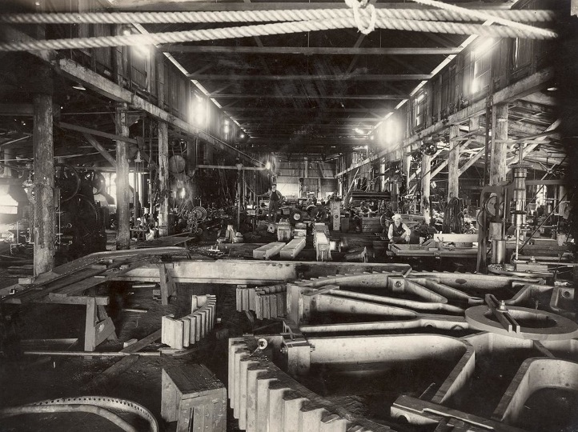
Figure 1. Example (Public Domain). (IJPME Figure caption)
Explain all symbols and abbreviations used. Make sure you use uniform lettering and sizing of your original artwork. In the captions use the key Word “Table” or “Figure” at the begining according to item, at the top for “table” and to the bottom for “figure”. Text inside the table must be formatted up to 9 point.
Size the illustrations close to the desired dimensions of the printed version. Vector graphics instead of rasterized images – should be used for diagrams and schemas whenever possible. Please check that the lines in line drawings are not interrupted and have a constant width. Line drawings are to have a resolution of at least 800 dpi.

Equations and Formulas
Displayed equations or formulas are centered and set on a separate line (with an extra line space above and below).

x = a² + b² (1)

Displayed expressions should be numbered for reference. The numbers should be consecutive within the contribution, with numbers enclosed in parentheses and set on the right margin.

Footnotes
Footnotes or endnotes will NOT be accepted.

Appendices
If needed, authors can add appendices to the document, that include complementary material useful to other researchers (e.g., questionnaires used in surveys, program code, etc.). Appendices will be placed after the references section, and they must be labelled using roman numerals (Appendix I, II, ...), and should have a title descriptive of its contents. This should always be a run-in heading and not a section or subsection heading.

References
Citations in the text should follow the referencing style used by the American Psychological Association (http://www.apastyle.org). For specific information on documenting particular sources, consult a style guide such as Publication Manual of the American Psychological Association or A Writer's Reference.
Each print sources (book, chapter in a edited book, periodical journal, periodical magazine and periodical newspaper) and electronic sources (internet or database) has it own defined style.
References in the text should be cited thus: Anthony (1965) (IJPME Link) or (Anthony, 1965); two authors: Gliffer and Thompson (1960) or (Gliffer and Thompson, 1960); three or more authors, Lasi et al. (2014) or (Lasi et al., 2014). References to papers by the same author(s) in the same year are distinguished in text and reference list by the letters a, b etc.
References must be listed at the end of the paper in alphabetical order and then further sorted chronologically if necessary. This should always be a run-in heading and not a section or subsection heading. It should be single spaced on one side and 9 point font size.

Data Availability
The data is available in the XXXX (public) data repository (in case of use). The data repository can assign a DOI to your data. This DOI should be indicated to link with them.

Acknowledgements
It should not be assigned a number. The acknowledgements may include reference to grants or supports received in relation to the work presented in the paper.

Authors contribution
Specify the contribution of each author of your manuscript.

References
Anthony, R. N. (1965). Planning and control systems: a framework for analysis. Division of Research, Graduate School of Business Administration, Harvard University. (IJPME References)
Giffler, B., & Thompson, G. L. (1960). Algorithms for solving production-scheduling problems. Operations research, 8(4), 487-503. https://doi.org/10.1287/opre.8.4.487
Lasi, H., Fettke, P., Kemper, H. G., Feld, T., & Hoffmann, M. (2014). Industry 4.0. Business & information systems engineering, 6(4), 239-242. https://doi.org/10.1007/s12599-014-0334-4
Vicéns-Salort, E., Gómez-Gasquet, P., Boza , A., Franco, R. D., Mula, J., & Cuenca, M. L. (2013). The first numer of IJPME: An exciting challenge. International Journal of Production Management and Engineering (IJPME), 1(1), 1-2. https://doi.org/10.4995/ijpme.2013.1565

