Click here, type the title of your paper, Capitalize first letter (Times New Roman 18 pt, bold, centered)
First Authorª, Second Author^{b}, Third Author^{a,b,*}
(Times New Roman 12 pt., bold, centered)

* Correspondence: email of the corresponding author
Received: 16 January 2018; Accepted: 26 February 2018; Published: 1 March 2018
Academic Editor: First name, Last name
(Times New Roman 10 pt., centered, line spacing 1)
Abstract (Times New Roman 11 pt., bold)
Click here and insert your abstract text. Please strictly follow the guidelines of the journal.
Format all the manuscript as follows: files must be in MS Word format only, paper size A4, Times New Roman 11 pt., justified text, line spacing 1.5, Custom margins: top (2.5 cm), bottom (2.5 cm), left (3 cm), right (2.5 cm).
http://polipapers.upv.es/index.php/MUSE/about/submissions#onlineSubmissions
Please provide complete affiliation of all authors of the manuscript and their ORCID number (https://orcid.org/)
The abstract must less than 250 words and the length of the article must be between 4000 and 8000 words.
Note that MUSE journal only publishes two issues per year, which is translated in around 12 papers. Then once your article is accepted its publication may take some time.
Please make sure your text is written in good English (American or British usage is accepted, but not a mixture of these) and that there are not grammatical errors throughout the manuscript.
Keywords: Type your keywords here, separated by semicolons; (5 maximum)

To cite this article (example): Llopis-Albert, C. Rubio, F., Valero, F. (2018). Optimization approaches for robot trajectory planning. Multidisciplinary Journal for Education, Social and Technological Sciences, 5(1), 1-16. https://doi.org/10.4995/muse.2018.9867.

(Maximum one page: Title + Affiliations + Abstract + Keywords + To cite this article)
1. Main (Times New Roman 13 pt., bold)
Here introduce the manuscript. The section headings and subheadings are arranged by numbers. Leave a clear line between sections or subsections.
(Times New Roman 11 pt., justified text, line spacing 1.5, indent the first line of each paragraph: 0.8 cm, space between paragraphs: 10 pt.)

1.1. Structure (Times New Roman 11 pt., bold)
For this journal the files must be in MS Word format only and should be formatted for direct printing. Figures and tables should be embedded and not supplied separately. Please make sure that you use as much as possible normal fonts in your documents. Special fonts, such as fonts used in the Far East (Japanese, Chinese, Korean, etc.) may cause problems during processing. To avoid unnecessary errors you are strongly advised to use the ‘spellchecker’ function of MS Word. Follow this order when typing manuscripts: Title, Authors, Affiliations, Abstract, Keywords, Main text (including figures and tables), Acknowledgements, References, Appendix.
Bulleted lists may be included and should look like this:
- First point
- Second point
- And so on
Please do not alter the formatting and style layouts which have been set up in this template document. As indicated in the template, papers should be prepared in single column format suitable for direct printing onto A4 paper (192mm x 262 mm). Leave a line clear between sections or subsections.

1.2. Tables (Times New Roman 11 pt., bold)
All tables should be numbered with Arabic numerals. Headings should be placed above tables, left justified. Leave one-line space between the heading and the table. Only horizontal lines should be used within a table, to distinguish the column headings from the body of the table, and immediately above and below the table. Tables must be embedded into the text and not supplied separately. Below is an example which authors may find useful. See Table 1.

Table 1 (Bold) An example of a table. (Times New Roman 10 pt., single-spaced format)
An example of a column heading | Column A | Column B
And an entry | 1 | 2
And another entry | 3 | 4
And another entry | 5 | 6

1.3. Construction of references (Times New Roman 11 pt., bold)
References should be added at the end of the paper, and its corresponding citation will be added in the order of their appearance in the text. Authors should ensure that every reference in the text appears in the list of references and vice versa. Indicate references by Llopis-Albert et al. (2019) or Llopis-Albert and Rubio (2018); Llopis-Albert (2019) in the text. The actual authors can be referred to, but the reference citation(s) must always be given.
Some examples of how your references should be listed are given at the end of this template in the ‘References’ section, which will allow you to assemble your reference list according to the correct format and font size.

1.4. Section headings (Times New Roman 11 pt., bold)
Section headings should be left justified, with the first letter capitalized and numbered consecutively, starting with the Introduction. Sub-section headings should be in capital and lower-case letters, numbered 1.1, 1.2, etc, and left justified, with second and subsequent lines indented. You may need to insert a page break to keep a heading with its text.

1.5. General guidelines for the preparation of your text (Times New Roman 11 pt., bold)
Avoid hyphenation at the end of a line. Symbols denoting vectors and matrices should be indicated in bold type. Scalar variable names should normally be expressed using italics. Weights and measures should be expressed in International System (SI) units.

1.6. Footnotes (Times New Roman 11 pt., bold)
Footnotes should be avoided if possible. Necessary footnotes should be denoted in the text by consecutive superscript letters. The footnotes should be typed single spaced, and in smaller type size (Times New Roman 9 pt.), at the foot of the page in which they are mentioned, and separated from the main text by a short line extending at the foot of the column.

2. Author Artwork (Times New Roman 13 pt., bold)
All figures should be numbered with Arabic numerals (1, 2, ..., n). All photographs, schemas, graphs and diagrams are to be referred to as figures. Line drawings should be good quality scans or true electronic output. Low-quality scans are not acceptable. Figures must be embedded into the text and not supplied separately. Lettering and symbols should be clearly defined either in the caption or in a legend provided as part of the figure. Figures should be placed at the top or bottom of a page wherever possible, as close as possible to the first reference to them in the paper.
The figure number and caption should be typed below the illustration in Times New Roman 10 pt. and centered. Artwork has no text along the side of it in the main body of the text. However, if two images fit next to each other, these may be placed next to each other to save space, see Fig 1. They must be numbered consecutively, all figures, and all tables respectively.

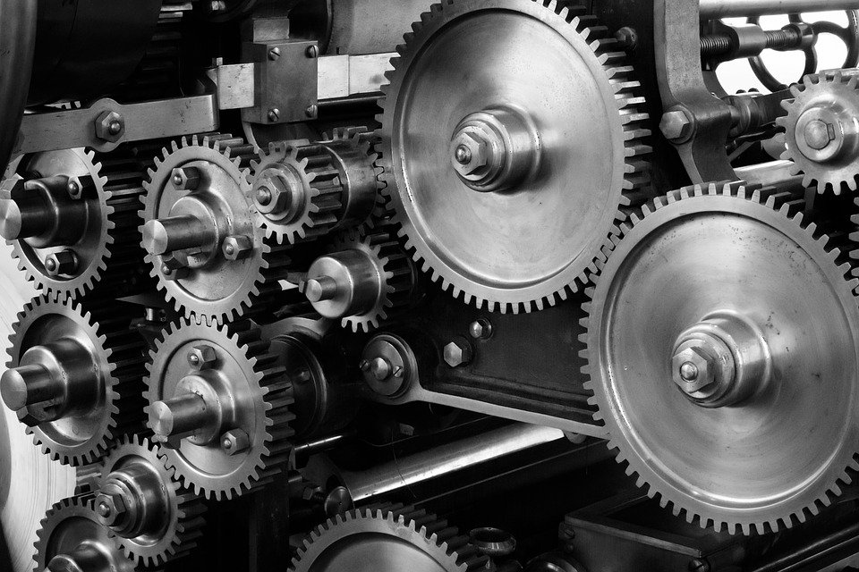
Figure 1. (a) first picture; (b) second picture (Times New Roman 10 pt.)

Equations and formulae should be typed and numbered consecutively with Arabic numerals in parentheses on the right-hand side of the page (if referred to explicitly in the text),
$\sum_{k=0}^{n}{\left(\begin{matrix}n \\ k\end{matrix}\right)=}2^{n}$ (1)
They should also be separated from the surrounding text by one space. See Eq. (1).

Acknowledgements: This and the following headings are in bold but have no numbers. Text below continues as normal. In this section, you can acknowledge any support given which is not covered by the author contribution or funding sections. This may include administrative and technical support, or donations in kind (e.g., materials used for experiments).
Author Contributions: For research articles with several authors, a short paragraph specifying their individual contributions must be provided. The following statements should be used “Conceptualization, X.X. and Y.Y.; methodology, X.X.; software, X.X.; validation, X.X., Y.Y. and Z.Z.; formal analysis, X.X.; investigation, X.X.; resources, X.X.; data curation, X.X.; writing original draft preparation, X.X.; writing review and editing, X.X.; visualization, X.X.; supervision, X.X.; project administration, X.X.; funding acquisition, Y.Y. All authors have read and agreed to the published version of the manuscript.” Please turn to the CRediT taxonomy for the term explanation. Authorship must be limited to those who have contributed substantially to the work reported.
Funding: Please add: “This research received no external funding” or “This research was funded by NAME OF FUNDER, grant number XXX”. Check carefully that the details given are accurate and use the standard spelling of funding agency names at https://search.crossref.org/funding. Any errors may affect your future funding.
Conflicts of Interest: Declare conflicts of interest or state “The authors declare no conflict of interest.” Authors must identify and declare any personal circumstances or interest that may be perceived as inappropriately influencing the representation or interpretation of reported research results. Any role of the funders in the design of the study; in the collection, analyses or interpretation of data; in the writing of the manuscript, or in the decision to publish the results must be declared in this section. If there is no role, please state “The funders had no role in the design of the study; in the collection, analyses, or interpretation of data; in the writing of the manuscript, or in the decision to publish the results”.
Data Availability Statement: This section is not mandatory. In this section, please provide details regarding where data supporting reported results can be found, including links to publicly archived datasets analyzed or generated during the study. You might choose to exclude this statement if the study did not report any data.
Patents: This section is not mandatory but may be added if there are patents resulting from the work reported in this manuscript.
Supplementary Materials: This section is not mandatory. They are available online at https://polipapers.upv.es/index.php/MUSE, Figure S1: title, Table S1: title, Video S1: title.

References (Times New Roman 10 pt., bold)
Please pay special attention to the reference section and strictly follow the journal style.
The American Psychological Association (APA) Style should be used for the reference section: https://www.apastyle.org/
To ensure quality and state-of-the-art research most of the citations should be recent articles indexed in the Journal Citation Report (Clarivate Analytics).
Please relate your work with previous articles of MUSE journal (at least one paper and no more than three) to make sure that it falls within the scope of the journal. This also helps the editorial team to determine the suitability of the manuscripts to MUSE.
Please provide complete reference details:
-Provide the complete digital object identifier (DOI) link, volume, issue and page number.
-For conferences: publisher name, location, and date.
-No more than 3 self-citations are allowed.
Examples (Hanging indent: 0.8 cm):
Llopis-Albert, C. Rubio, F., Valero, F. (2018). Optimization approaches for robot trajectory planning. Multidisciplinary Journal for Education, Social and Technological Sciences, 5(1), 1-16. https://doi.org/10.4995/muse.2018.9867.
Llopis-Albert, C. Rubio, F., Valero, F. (2018a). Designing efficient material handling systems via Automated Guided Vehicles (AGVs). Multidisciplinary Journal for Education, Social and Technological Sciences, 5(2), 97-105. https://doi.org/10.4995/muse.2018.10722.

Appendix A. An example appendix (Times New Roman 11 pt., bold)
Authors including an appendix section should do so after References section. Multiple appendices should all have headings in the style used above. They will automatically be ordered A, B, C etc. The appendix is an optional section that can contain details and data supplemental to the main text.
A.1. Example of a sub-heading within an appendix (Times New Roman 11 pt., bold)
There is also the option to include a subheading within the Appendix if you wish.

